**Enhancing Network Resilience against Distributed Denial-of-Service (DDoS) Attacks**

By

Bhavani Siva Jyothi

**Z23748131**

**ABSTRACT**

The emergence of malicious applications and urls poses a significant risk to the Android operating system. Various network interfaces use integrated functionalities to collect consumers' personal information and initiate the necessary steps for an attack. This research presents a novel approach for automatically detecting malware by analyzing the textual characteristics of network web traffic. Specifically, we see each HTTP flow generated by mobile apps as a textual document, which may be enhanced by natural language processing to extract text-level characteristics. Subsequently, network website traffic is used to create an effective virus detection model. We use the N-gram technique from natural language processing (NLP) to assess the traffic circulation header. Next, we propose an approach that utilizes chi-square analysis to automatically identify meaningful functions. It is used to determine whether there is a significant correlation between the two variables. We propose a distinctive service that use NLP techniques to detect malware ddos. This is achieved by considering mobile traffic as individual data entries. We use an automated algorithm that selects attributes based on N-gram sequences in order to derive significant functions from the semiotics of traffic flows. Our methodologies expose some malware that has the ability to evade detection by antivirus scanners. Furthermore, we have developed a discovery system that effectively directs traffic to your institutional business network, home network, and Url data . Integrating the computer system with the network to identify suspicious network activities.

**INTRODUCTION**

**1.1 MOTIVATION**

The emergence of malicious apps poses a significant threat to the Android platform.   
Most types of network user interfaces that rely on integrated features collect users' personal information and initiate attack operations.   
This research presents a novel and efficient method for detecting malware by analyzing the textual meaning of network web traffic.   
Specifically, we consider each HTTP flow generated by mobile apps as a message document that may undergo natural language processing to eliminate text-level features.   
Subsequently, network traffic is used to create an effective malware detection model.   
  
**1.2 Definition of the Problem**   
Software Defined Network (SDN) is a nascent networking architecture that enhances the limitations of conventional network infrastructure. SDN streamlines policy enforcement and network setup by centralizing the control plane to a controller. In addition, the networking equipment are simplified, resulting in cost savings.   
While SDN offers advantages like centralized control and network flexibility, it is equally susceptible to network security attacks, such as Distributed Denial of Service (DDoS) attacks.   
Of all the types of DDoS attacks, TCP SYN flooding attacks are widely recognized as one of the most prevalent and impactful. TCP SYN attack exploits vulnerabilities in the Transmission Control Protocol (TCP). The adversary establishes many semi-open TCP connections on the targeted server with the intention of undermining its performance. Furthermore, when used in the context of SDN, the TCP SYN flooding assault also brings about a control aircraft saturation attack. The attacker generates a large quantity of TCP SYN packets, causing the data aircraft switches to direct them to the controller. Consequently, the controller's efficiency deteriorates, perhaps resulting in an inability to respond promptly to legitimate requests. In the worst-case scenario, the assault might cause a network disruption.   
This thesis proposes a semi-supervised machine learning algorithm that utilizes a Logistic Regression classifier to detect TCP SYN flooding assaults in SDN. The algorithm takes use of the dynamic programmability of SDN to identify these attacks. We have used four essential characteristics (Packages, Bytes, Circulations, and One_Packet) to train our LR classifier offline. The prediction model derived from offline training is then used in online attack detection, while also continuing to classify incoming traffic in order to enhance the training dataset for classifier retraining. We will definitely do expansion experiments on the POX controller and evaluate its performance in various attack scenarios.   
**The objective of the task is to achieve a certain goal.**   
The objective of this research study is to detect Distributed Denial of Service (DDoS) attacks by using the unique feature of Software-Defined Networking (SDN) architecture. The main contributions of this thesis are:   
1. Propose a semi-supervised machine learning method for detecting DDoS attacks.   
2. Deploy the suggested semi-supervised algorithm in the Software-Defined Networking (SDN) environment.

**LITERATURE SURVEY**

**2.1 INTRODUCTION**

The appearance of malicious applications poses a substantial threat to the Android platform.   
Most types of network interfaces rely on integrated functionality to extract people' personal information and initiate attack operations.   
This research proposes a very efficient and automated method for detecting malware by analyzing the textual semantics of network website traffic.   
Specifically, we analyze each HTTP transaction generated by mobile apps as a textual document, which may be refined using natural language processing to eliminate text-level characteristics.   
Subsequently, network data is used to create an effective model for detecting malware.   
  
**2.2 CURRENT SYSTEM**   
The first phase of their strategy involves categorizing the incoming network traffic into three different methods: TCP, UDP, or other miscellaneous protocols. Next, the data is categorized as either normal or abnormal traffic. In the second step, a multi-class formula is used to identify the irregularity detected in the first phase. This helps predict the course of the attacks and choose the most suitable therapy. This research utilizes two specific public information sets for conducting experiments: the UNSW-NB15 and the NSL-KDD. Several methods have been proposed for detecting Distributed Denial of Service (DDoS) attacks. Information theory and machine learning are closely related fields. The effectiveness of network intrusion detection methods often depends on the distribution characteristics of the underlying network traffic data used for analysis. The DDoS detection methods in literature may be classified into two main categories: covert tactics and monitoring procedures. Depending on the benchmark data collections used, unsupervised methods often experience a high rate of false positives, and supervised techniques are unable to handle large amounts of network traffic data. Furthermore, their performance is often hindered by noisy and irrelevant network data. Hence, there is a need to integrate both supervised and unsupervised methodologies in order to address the issue of DDoS detection.   
  
**2.3 Drawbacks of the current system**   
The datasets are partitioned into training subsets and test subsets, with a predefined ratio of 60% for training and 40% for testing.   
The suggested approach comprises five pivotal actions: Preprocessing datasets, evaluating network traffic degradation, online carbon monoxide clustering, and analyzing details to determine the fraction.   
The goal of partitioning the anomalous network traffic is to decrease the amount of data that has to be categorized by omitting the usual data for the specific category.   
  
**The proposed system is version 2.4.**   
This section presents our methods for detecting DDoS attacks. The process of using data mining methods in network systems is described as a five-fold activity, which is outlined in the defined methodology.The primary goal of integrating algorithms in the proposed strategy is to reduce noisy and unnecessary network web traffic data before preprocessing and categorization stages for DDoS detection, while maintaining high performance in terms of accuracy, false positive rate, running time, and minimal resource utilization. Our approach starts by evaluating the deterioration of the FSD components using a time-based sliding window. When the normal decrease of a time window above its lower or upper criteria, the co-clustering algorithm divides the obtained network web traffic into three clusters. The use of entropy estimation with temporal sliding windows enables the detection of sudden changes in the incoming network traffic flow, often caused by Distributed Denial of Service (DDoS) attacks. Network traffic that enters the system at certain time periods and shows unusually low levels is considered to be DDoS activity. The focus only on the assumed time periods enables the filtering of a significant amount of network web traffic data, ensuring that only relevant information is selected for the subsequent steps of the proposed approach. Furthermore, vital resources are preserved in the absence of any abnormal deterioration. To identify the regular cluster, we estimate the information gain ratio by comparing the average degradation of the FSD features between the collected network traffic data during the current time frame and each of the obtained clusters. As mentioned before, during a DDoS assault, the volume of malicious online traffic is often more than the normal web traffic. Therefore, by estimating the information gain ratio using the FSD, it becomes possible to identify both the cluster that has more information about the DDoS assault and the cluster that just contains ordinary traffic. Consequently, the cluster that produces a lower information gain ratio is classified as normal, while the rest clusters are classified as anomalous. The details gain ratio is computed for each cluster in accordance with the following:   
**Benefits of the proposed system**   
Reduce the amount of noisy information before to doing preprocessing and categorization tasks.   
Light Heavy web Application.   
Clustering methods are used.

**REQUIREMENT SPECIFICATIONS**

**3.1 INTRODUCTION**

Purpose: The primary aim of creating this document is to provide a comprehensive understanding of the assessment and needs of the current system or scenario, as well as to ascertain the operational features of the system.   
Scope: This document plays a vital role in the software development life cycle (SDLC) and it outlines the whole system requirements. This tool is intended for use by designers and will be essential throughout the screening process. Any alterations made to the requirements in the future will undoubtedly have to undergo a formal procedure of permission for change.

**3.2 SOFTWARE REQUIREMENTS**

|  |  |
| --- | --- |
| **IDE** | **OS** |
| **1. Python**  **2. Django**  **3. MySql**  **4. MySqlclient**  **5. WampServer 2.4** | Works on windows operating system |

Table 3.2: Software Requirements:

**3.3 HARDWARE REQUIREMENTS**

|  |  |
| --- | --- |
| Processor | Intel I3 and above |
| DISK Space | 10GB |
| RAM | 4GB and higher |

Table 3.3: Hardware Requirements:

**CHAPTER- 4**

**MODULES DESCRIPITION**

* User Apps
* DDOS Attack Deduction
* Classifications of DDOS attack
* Graphical analysis

|  |  |
| --- | --- |
| **module** | **Description** |
| **1.User Apps** | User handling for some various times of smart phones ,desktops  laptops and tablets |
| **2.DDOS Attack Deduction** | User search the any link Notably, not all network traffic data generated  by malicious apps correspond to malicious traffic. |
| **3.Classifications of DDOS Attack:** | compare the classification performance of Co-clustering  algorithm |
| **4.Graphical analysis** | The graph analysis is done by the values taken from the result analysis  part and it can be analyzed by the graphical representations. |

Table 4.1: User module

**DESIGN AND ANALYSIS**

**5.1. INTRODUCTION**

Software layout is a crucial aspect of the software design process, regardless of the level of technology or the specific application field. Style is the first phase in the development of any designed object or system. The objective of the developer is to construct a model or depiction of an entity that will subsequently be constructed. System design is the first step in the process of constructing and verifying a software program, after the definition and analysis of system requirements. It is one of the three technical activities, together with layout, code, and inspection. The value may be succinctly expressed as "Quality". Design is the place where excellence is cultivated in software development. Style offers us with models of software applications that may be analyzed for quality. Layout is the only method by which we can accurately translate a client's vision into a finalized software product or system. Software program layout functions as a framework for all subsequent software program engineering activities. In the absence of a robust style, there is a risk of creating an erratic system, which would be difficult to evaluate and whose quality cannot be assessed until the final stage. During the process of style, the information structure, program framework, and procedural details are produced, evaluated, and documented via continual refinement. The system's style may be seen from either a technical or task monitoring perspective. Technologically speaking, style encompasses four tasks: architectural design, information structure design, user interface layout, and step-by-step design.   
  
**5.2 UML DIAGRAMS**   
A UML layout provides a comprehensive visual representation of the UML (Unified Modelling Language) system. Its objective is to help designers and business owners get a deeper understanding of the structure and behaviours of their system, enabling them to analyze and implement it more effectively. In simpler terms, this pattern is quite similar to blueprints used in construction projects. The UML diagram has emerged as a popular tool for modelling corporate procedures and has proven effective for large and complex projects. UML plays a crucial role in the creation of object-oriented software programs by providing explicit and straightforward notations.   
UML diagramming offers several benefits for both software application developers and business professionals, with the most crucial ones being:   
Enterprises have the opportunity to enhance the quality of their products and decrease costs, especially for complex systems on a big scale, via problem-solving. Several other real-world concerns, such as the transportation of goods or ensuring safety and security, may be effectively addressed. Enhance Efficiency - Utilizing the UML model ensures that all team members are aligned and saves significant time in the future.   
The UML diagram provides a clear and expressive presentation of the requirements, features, and procedures of a system, which is beneficial for various functions such as stakeholders, designers, or organization scientists, who may not be professional programmers.   
  
**Example of use**   
A use scenario is a technique employed in system assessment to ascertain, elucidate, and structure system requirements. Usage scenario diagrams are used in UML, which is a standard set of symbols used for representing real-world objects and systems. A use scenario depiction consists of four components.   
The limit, which establishes the framework for the interest rate system in relation to the global economy. The actors are individuals who are often associated with the system based on their specific roles and responsibilities. The utilization scenarios include the specific roles performed by the celestial bodies inside and around the system. The links among the actors and the use cases.

**Use case diagram**

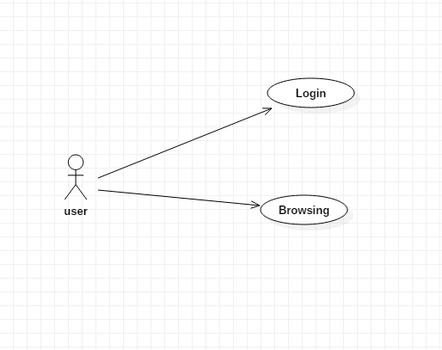

Fig 5.2.1 use case diagram for user interaction

**ACTIVITY**

Activity diagrams are graphical representations of processes that include actions and tasks with support for choice, version, and concurrency. One tool in the Unified Modelling Language toolbox is the task diagram, which is used to illustrate the service and functional processes that flow through a system's components. An activity layout may show the overall control flow.

**Activity diagram for**

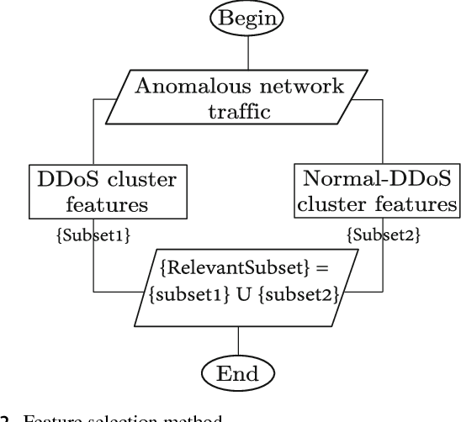

Fig 5.2.2: Activity diagram

The deployment of an application to Android is shown here in an example of a UML release structure. Android is a smartphone software stack that includes an OS, middleware, and essential apps. The fundamental system functions provided by Linux OS, including security, memory management, process management, network stack, and driver architecture, are essential to Android. In addition to bridging the gap between hardware and software, the Linux kernel provides an abstraction layer.   
The language used to create Android apps is Java. Code, together with any necessary data and source files, is assembled and packaged into Android application archive documents with a.apk suffix by use of the Android SDK tools. One Android program, represented by the.apk files, is ready for distribution to mobile devices that can run the Android operating system.

**Deployment Diagram**

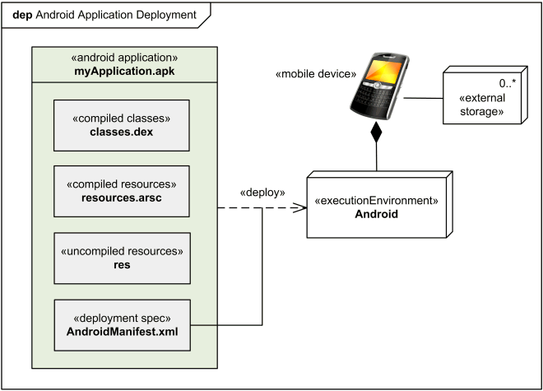

Fig 5.2.5: Deployment Diagram

What makes up an Android app are its activities, solutions, material firms, and content receivers. A number of its components—some of which may be engaged separately and others with which other applications interact—control the application's overall behaviours.   
 **PART**A component's behaviour is defined by the interfaces it provides and the interfaces it requests; these interfaces are sometimes available via ports.   
Each component, together with its provided and necessary interfaces, ports, and interconnections, is represented by a part. Component-Based Advancement (CBD) continues to be one application that uses these representations for modelling SOA systems.   
Instead of explaining how the system works, the Part Diagram shows all the parts that go into making it work.

**Component diagram for browsing**

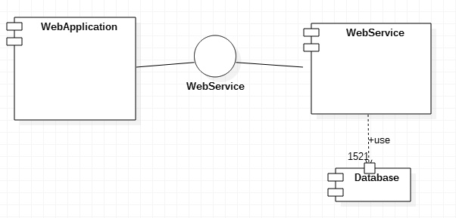

Fig 5.2.6: Component Diagram For Browsing

Each piece of a Part Diagram has a purpose. This feature is accessed via an application. Here, an online app is what really makes use of the internet service. You need to know the exact way to contact that Web Solution before you can use it. Hence, an Interface needs to be provided by the Internet Solution. An interface specifies the means by which you may get to that component. In order to enhance the functionality of the Internet Solution, this interface is also used. A class-like construct that just includes constants and abstract methods is an interface.  **REPORT FORM**In computer science and related domains, a state diagram is a representational tool for explaining system behaviour. For state layouts to work, the described system must have a small number of states.

**State chart diagram**

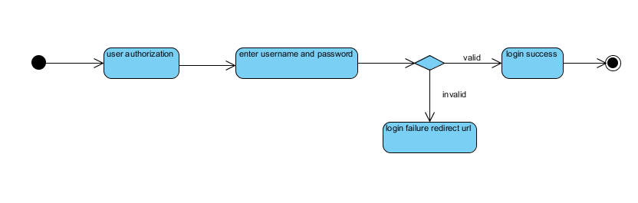

Fig 5.2.7: State chart diagram

**COMPONENT**

A software system or component may be represented visually by a component layout, which shows how smaller pieces are interconnected. It is possible to use them to uncover the structure of systems of arbitrarily complex types.

**Component diagram**

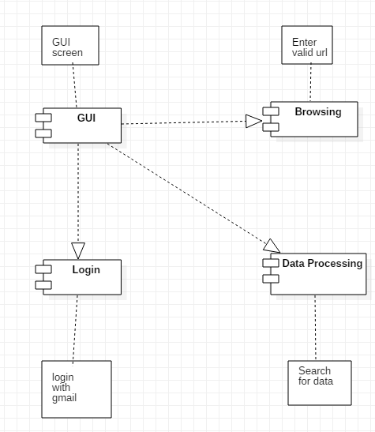

Fig 5.2.8: Component diagram

**COLLABORATION**

Partnership layouts show the real-time interactions and interdependence's between various system components, much like flowcharts. Rectangles with calling tags show what the items are. These tags might be highlighted or preceded by colons. Lines drawn between the rectangular forms show the connections between the objects. The communications between objects are shown by arrows linking the appropriate rectangles and labels that describe the message sequencing.

**Collaboration diagram**

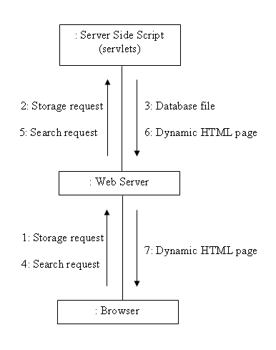

Fig 5.2.9: Collaboration diagram

**CHAPTER- 6**

**IMPLEMENTATION AND RESULTS**

**6.1. INTRODUCTION**

Your Android app has to include a Web View. The term "Web View" refers to a specific kind of view that mimics the functionality of an Android Net Web Browser. This means you may demonstrate some online web content inside your Task or even create your own web browser. Among the many features included in an Internet Sight are the ability to do text searches, focus and out, go forward and backward via a backdrop, and utilize the Web Kit providing engine to display webpages. We will create a two-button activity where the first button will load a website and the second button will pack a custom HTML content into an Internet Sight.   
Create an Android workshop job from scratch. Launch the Android Application Task by selecting File > New.   
Give your job a name and fill out the form.   
  
**6.2 Method of Implementation.**   
Python, MYSQL, Java, and the following are the main tools used in this project.   
Among the many popular SQL data source management systems, MySQL stands out as an open-source option. When it comes to relational database management systems, MySQL is among the top choices used to build a wide variety of web-based applications. MySQL ABDOMINAL MUSCLE is a Swedish firm that develops, markets, and supports MySQL. If you're new to MySQL and want to learn the ropes, this is the course for you.   
An alternative program that stores a set of data is called a data source. One or more application programming interfaces (APIs) are available for each data source, allowing users to build, access, manage, search, and duplicate data.   
Files on the data system or huge hash tables in memory are two further examples of possible data storage; however, data reading and writing would not be as simple or quick with these systems.   
These days, we store and manage massive amounts of data via relational database management systems (RDBMS). This kind of database is known as a relational database since all the data is stored in separate tables and relationships are formed using key secrets or other methods called International Keys.   
**programming language.**   
Python has dynamic semantics and is a top-level, interpreted, object-oriented language. Its dynamic input, colourful binding, and top-level built-in information structures make it a desirable scripting or adhesive language for Rapid Application Advancement and for connecting existing pieces. Python's syntax is straightforward and simple to learn, which prioritizes readability and reduces the cost of program maintenance. Python encourages code reuse and software modularity with its support for bundles and components. Free and accessible in resource or binary form for all major systems, the Python interpreter and the huge standard library are publicly distributively and widely used.   
The enhanced performance that Python provides is a major selling point for programmers. The edit-test-debug cycle is lightning fast since there is no collection stage. Python program debugging is a breeze since segmentation faults are very rare and almost never caused by bugs or bad input. Instead, it raises an exception if the interpreter makes a mistake. The interpreter will release a stack trace if the program fails to catch the error. You may examine regional and global variables, approximate expressions, set breakpoints, walk through the code line by line, and more with a resource degree debugger. The debugger is a testament to Python's reflective capabilities as it is developed in Python. However, adding a few print statements to the resource is usually the fastest way to debug a program. This simple method is highly efficient due to the rapid edit-test-debug cycle.   
**Programming in JavaScript.**   
Internet Programming is known as JavaScript.   
JavaScript has the ability to modify and update both CSS and HTML.   
Data may be calculated, controlled, and confirmed using JavaScript.

**Results**

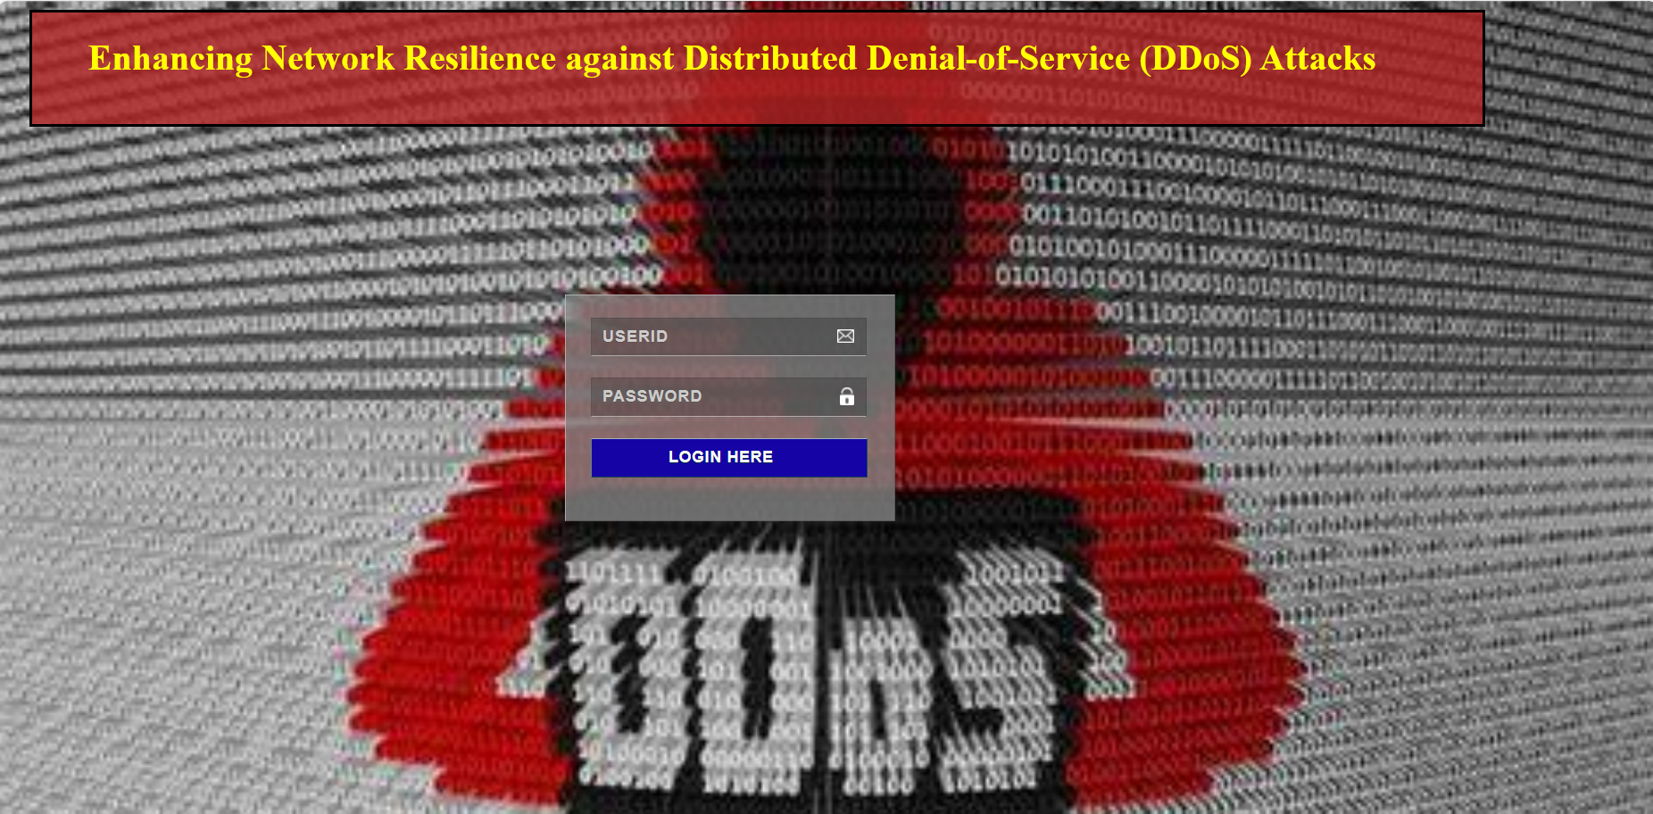

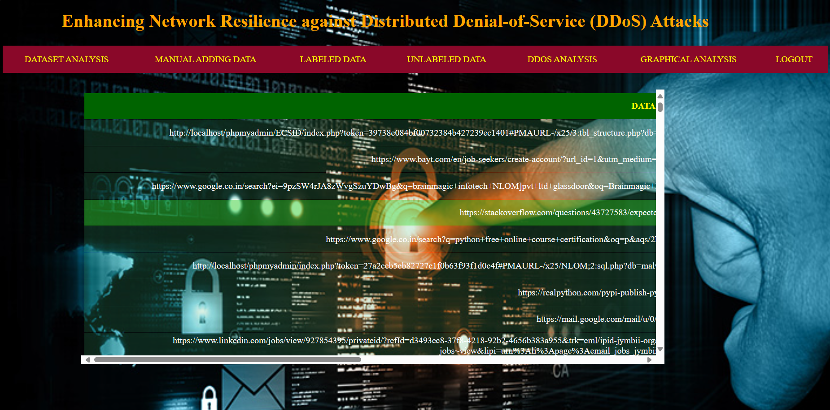

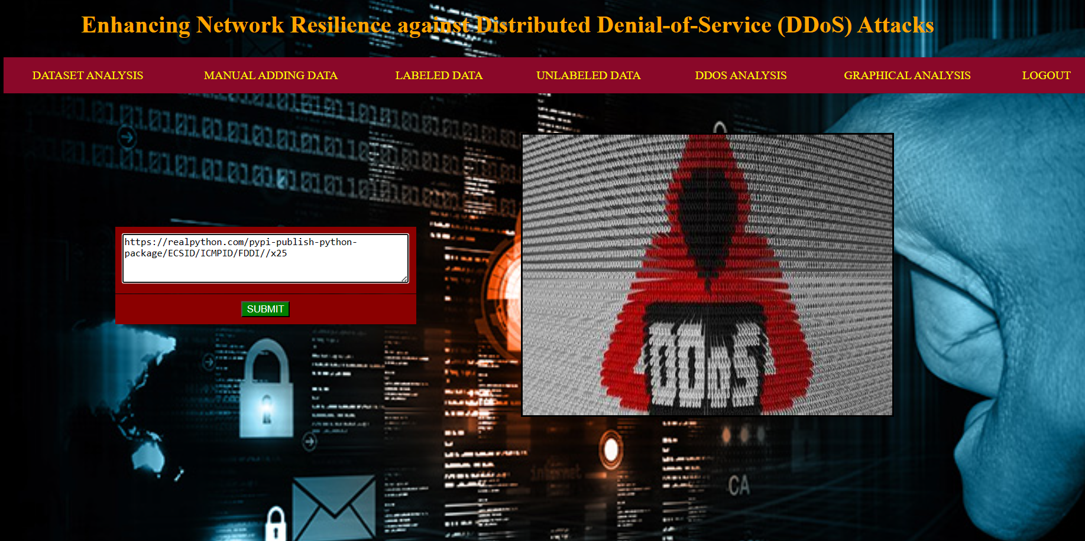



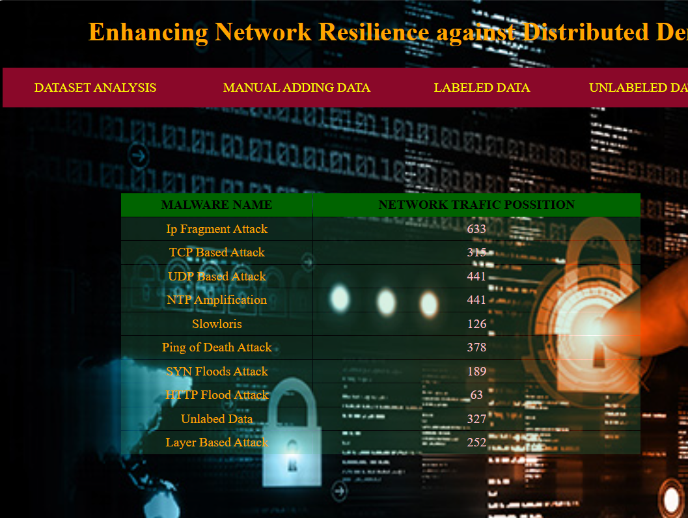

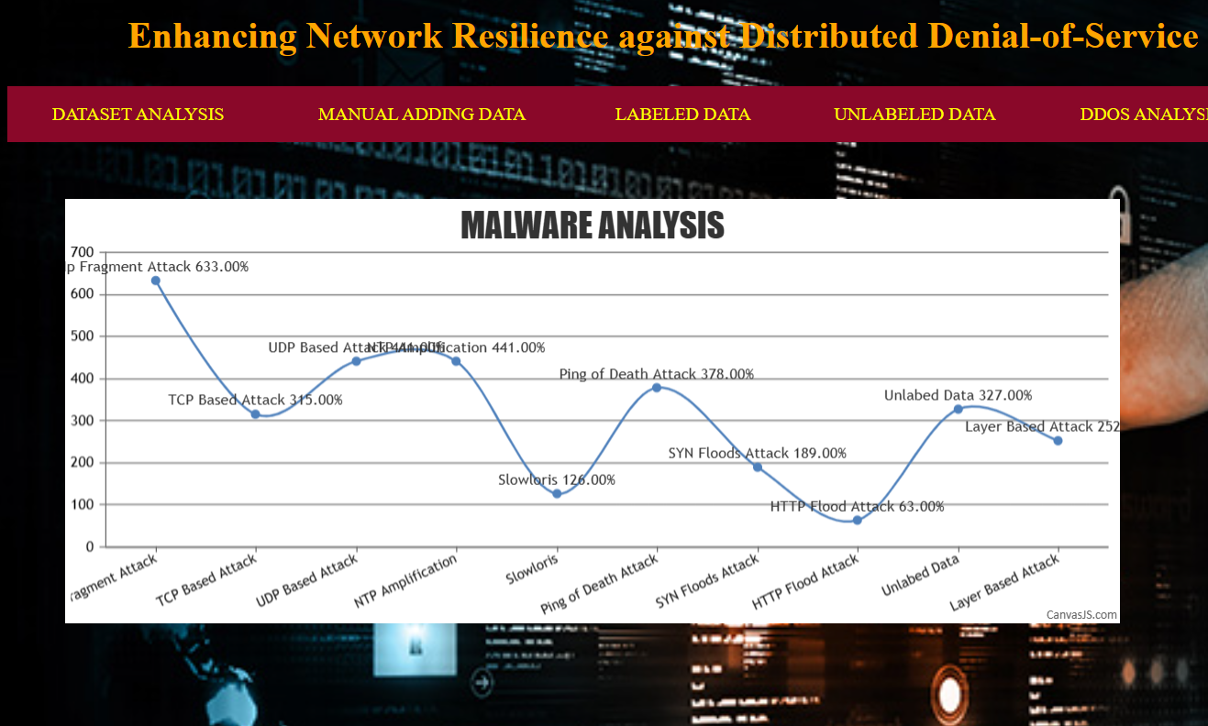

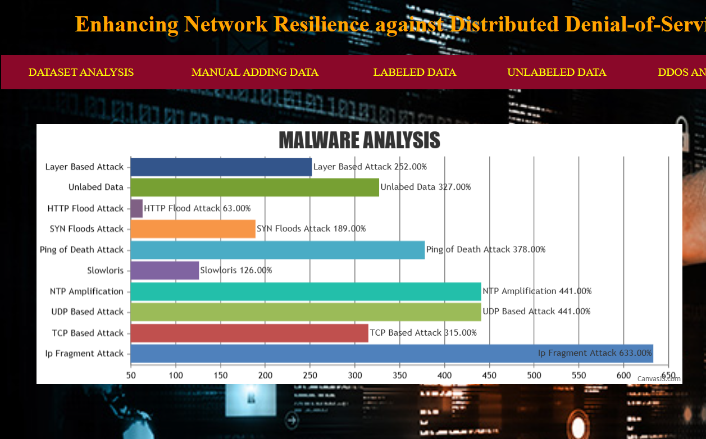

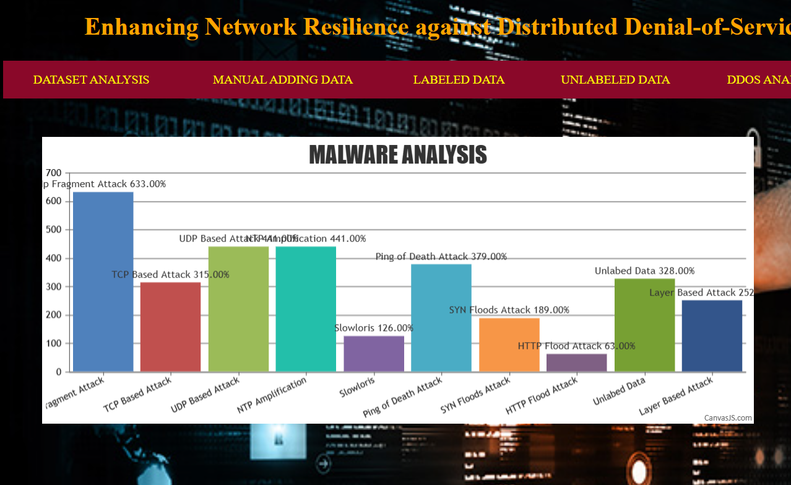

**TESTING AND VALIDATION**

**8.1 INTRODUCTION**

Screening and debugging are essential components of every computer system development process since, without properly functioning code, the system would never be able to provide the desired output. The most effective way to screen is to ask customer growth for help finding all defects and difficulties. The sample data is used for testing purposes. More important than the quantity of data used for testing is its high quality. Prior establishing rules for real process, testing ensures the system's correctness and efficiency.   
**Quite a Few Trials**Steps to take while evaluating individual units   
System testing ensures that the program's main logic is functioning correctly and that valid inputs produce valid outputs by generating test cases. It is critical to validate the inner code circulation and all decision branches. As part of this procedure, we'll check the functionality of certain code segments inside the program.Until every private unit is finished, integration cannot take place. To conduct this invasive structural screening, it is essential to have knowledge about its construction. To accomplish basic component-level screening, device testing might zero in on a certain business process, application, or system configuration. In order to ensure that all private organization process courses follow the stated standards and have clearly defined inputs and outputs, device screening is used.   
**Assessing integration**   
Designers create assimilation tests to ensure that many software programs can function as intended when combined. An event-driven test primarily focuses on producing a display or field output. Effective system screening demonstrated that the components were satisfactory individually, and assimilation tests confirmed that the combination is correct and regular. In integration testing, the goal is to find problems that arise when components are combined.   
**Assessing in practice**   
The goal of practical testing is to methodically prove that the evaluated features are easily accessible and meet the requirements specified in the user manual, system documentation, service and technical requirements, and any other applicable materials.   
It is common practice to assess the following during functional screening:   
Input is only valid if it fits into one of the predetermined categories.   
Disable any and all forms of incorrect input that have been found.   
It is necessary to carry out the designated tasks.   
It is important to determine application results based on the specified categories.   
Technical Aspect The necessary interface system or process must be invoked.   
Functional tests are designed and developed with an emphasis on requirements, critical features, or one-of-a-kind test scenarios. The steps taken by the company's processes, including data areas, defined procedures, and following procedures, must be thoroughly reviewed. Prior to functional screening being finished, more exams are identified and the efficient value of current testing is established.   
**Analyzing the Framework**   
Screening the system is crucial to make sure all the integrated software works as expected. It examines an arrangement to make sure the effects are well-known and predictable. One form of system test is the configuration-oriented system combination exam. Documents and procedure flows, particularly those pertaining to integration factors and pre-driven procedure linkages, form the basis of system testing.   
Carried Out White Box Evaluations   
The software application tester in white box testing is familiar with the program's purpose, architecture, and language, and has a grasp of the program's operation. That is the goal it aims toward. Look at areas that a black box level can't reach using this tool.   
**Registering for an Unknown Situation**   
Black box testing is the way to go if you want to test the performance, framework, or language of a software module but don't know anything about it. Black box testing, like many other types of testing, requires a final source document, such a specifications or requirements document, to be written. This method of screening treats the software under consideration as if it were a mysterious creature.Straight into it, you can't see. The test only takes in data and outputs results without considering the inner workings of the software program.   
**Evaluating the Tools**   
Device testing is often done as part of a mixed code and unit examination phase, however it is not unusual for the software program lifecycle to have two separate periods for coding and device testing.   
Plan ahead and administer the test   
There will most probably be extensive documentation of practical tests as well as hands-on testing in the field.   
Objectives of the test: All parts must function correctly.   
To access the pages, just click on the recognized web link.   
The input screen, messages, and answers must not experience any kind of delay.   
**Things needed for the test**   
Verify that the entries are in the correct sequence.   
Make sure that no two entries are the same. Inspect each link to make sure it leads to the correct page.   
**Thorough Evaluation**   
Software combination testing is the process of methodically creating failures due to interface flaws by assimilation screening several integrated software parts on a single system.   
The integration test looks for instances of software components or apps interacting without any errors. Parts of software systems or, even better, software applications used by businesses themselves could fall under this category.   
  
The results demonstrate that each of the previously proposed test cases was successful. We did not discover any defects.   
The target market is heavily involved in User Approval Testing (UAT), a crucial part of any job lifecycle. In addition, it ensures that the system meets the functional requirements.It was found that all of the aforementioned test conditions had passed. We did not discover any defects.

**8.2 VERIFICATION**

The set of Test Cases are used to test the functionality of each module if that module works properly then that Test Cases marked as Pass or else Fail.

|  |  |  |  |  |
| --- | --- | --- | --- | --- |
| Test Id. | Test Case | Input Description | Expected Output | Test Status |
| 1 | Sign-in | When user clicks on sign-in button open field box will be opened to select required Gmail | If user select the correct main he will get logged in | Pass |

Table 8.2: Verification

**8.3 VALIDATION**

The below table is used to determine whether or not a system satisfies the acceptance criteria and to determine whether or not to accept the system.

|  |  |  |  |
| --- | --- | --- | --- |
| SI no | Functions | Required Output | Actual Output |
| 1 | Search | Search for the required content | Valid page is loaded successfully |
| 2 | Invalid url format | Error message should be displayed | Error message is displayed if any interruptions occur |
| 3 | Displaying result | Text is displayed | Text contained in the web file is displayed |

Table 8.3: Validation

**CHAPTER-9**

**CONCLUSION**

**9.1CONCLUSION:**

Malware is quickly finding new and exciting targets on Android. The ever-expanding variety and scale of mobile malware is now undetectable by most antivirus programs and research methods. We provide a service that uses network traffic streams to identify mobile malware. This service treats each HTTP flow as a record and uses natural language processing string evaluation to analyze HTTP circulation requests. A useful malware finding design is created using the SVM algorithm, attribute choosing formula, and N-Gram line generation. Our results show that our solution works, and our expert version is far better than the current ones; it also finds harmful leaks with some false alarms. There is a 99.15% damage detection rate, but a 0.45% false positive rate for dangerous traffic. The effectiveness of the proposed approach is further confirmed by using the newly found malware. In real-world settings, the sample outperforms other well-known antivirus scanners by detecting 54.81% of malicious apps. The results of the test show that our design is detectable by malware versions, even if it doesn't manage to evade other virus scanners. Obtaining updated, harmful versions It is also possible to generate VirusTotal discovery reports. Among the items included, We will kindly request that you re-train, rejuvenate, and update the new malware whenever fresh tablets are added in the training samples.

**REFERENCES**

[1] opennetworking.org, “SDN Definition”, [Online]. Available:

[2] Diego Kreutz, Fernando M. V. Ramos, Paulo Verissimo,Christian Esteve Rothenberg Siamak

Azodolmolky, Steve Uhlig, “Software-Defined Networking: A Comprehensive Survey”,

[3] Wenfeng Xia, Yonggang Wen, Chuan Heng Foh, Dusit Niyato, Haiyong Xie, “A survey on

Software-Defined Networking”, IEEE Communication Surveys & Tutorials, Vol. 17, No. 1, First

[4] Seungwon Shin, Vinod Yegneswaran, Phillip Porras, Guofei Gu†, “AVANT-GUARD:

Scalable and vigilant switch flow management in software-defined networks,” in Proc. ACM

SIGSAC Conf. Comput. Commun. Security, Berlin, Germany, 2013, pp.

[5] Moreno Ambrosin, Mauro Conti , Fabio De Gaspari, and Radha Poovendran, “Lineswitch:

Efficiently managing switch flow in software-defined networking while effectively tackling dos

attacks,” in Proc. 10th ACM Symp. Inf. Comput. Commun. Security, Singapore, 2015, pp. 639–

[6] Narmeen Zakaria Bawany, Jawwad A. Shamsi, Khaled Salah, “DDoS Attack Detection and

Mitigation Using SDN Methods, Practices, and Solutions”, Arabian Journal for Science and

Engineering, February 2017, Volume 42, Issue 2, pp 425–441

[7] Tommy Chin, Xenia Mountrouidou, Xiangyang Li, Kaiqi Xiong, “An SDN-Supported

Collaborative Approach for DDoS Flooding Detection and Containment,” in Proc. IEEE Mil.

Commun. Conf. (MILCOM), Tampa, FL, USA, 2015, pp. 659–664.

[8] Mohan Dhawan, Rishabh Poddar, Kshiteej Mahajan, Vijay Mann, “Sphinx: Detecting security

attacks in software-defined networks,” in Proc. NDSS, San Diego, CA, USA, 2015.

[9] Reza Mohammadi, Reza Javidan, and Mauro Conti, “SLICOTS: An SDN-Based Lightweight

Countermeasure for TCP SYN Flooding Attacks”, IEEE TRANSACTIONS ON NETWORK

AND SERVICE MANAGEMENT, VOL. 14, NO. 2, JUNE 2017

[10] Nhu-Ngoc Dao, Junho Park, Minho Park, Sungrae Cho, "A Feasible Method to combat against

DDoS Attack in SDN Network," International Conference on Information Networking (ICOIN),

**APPENDIX**

**Source Code (data set preparation)**

